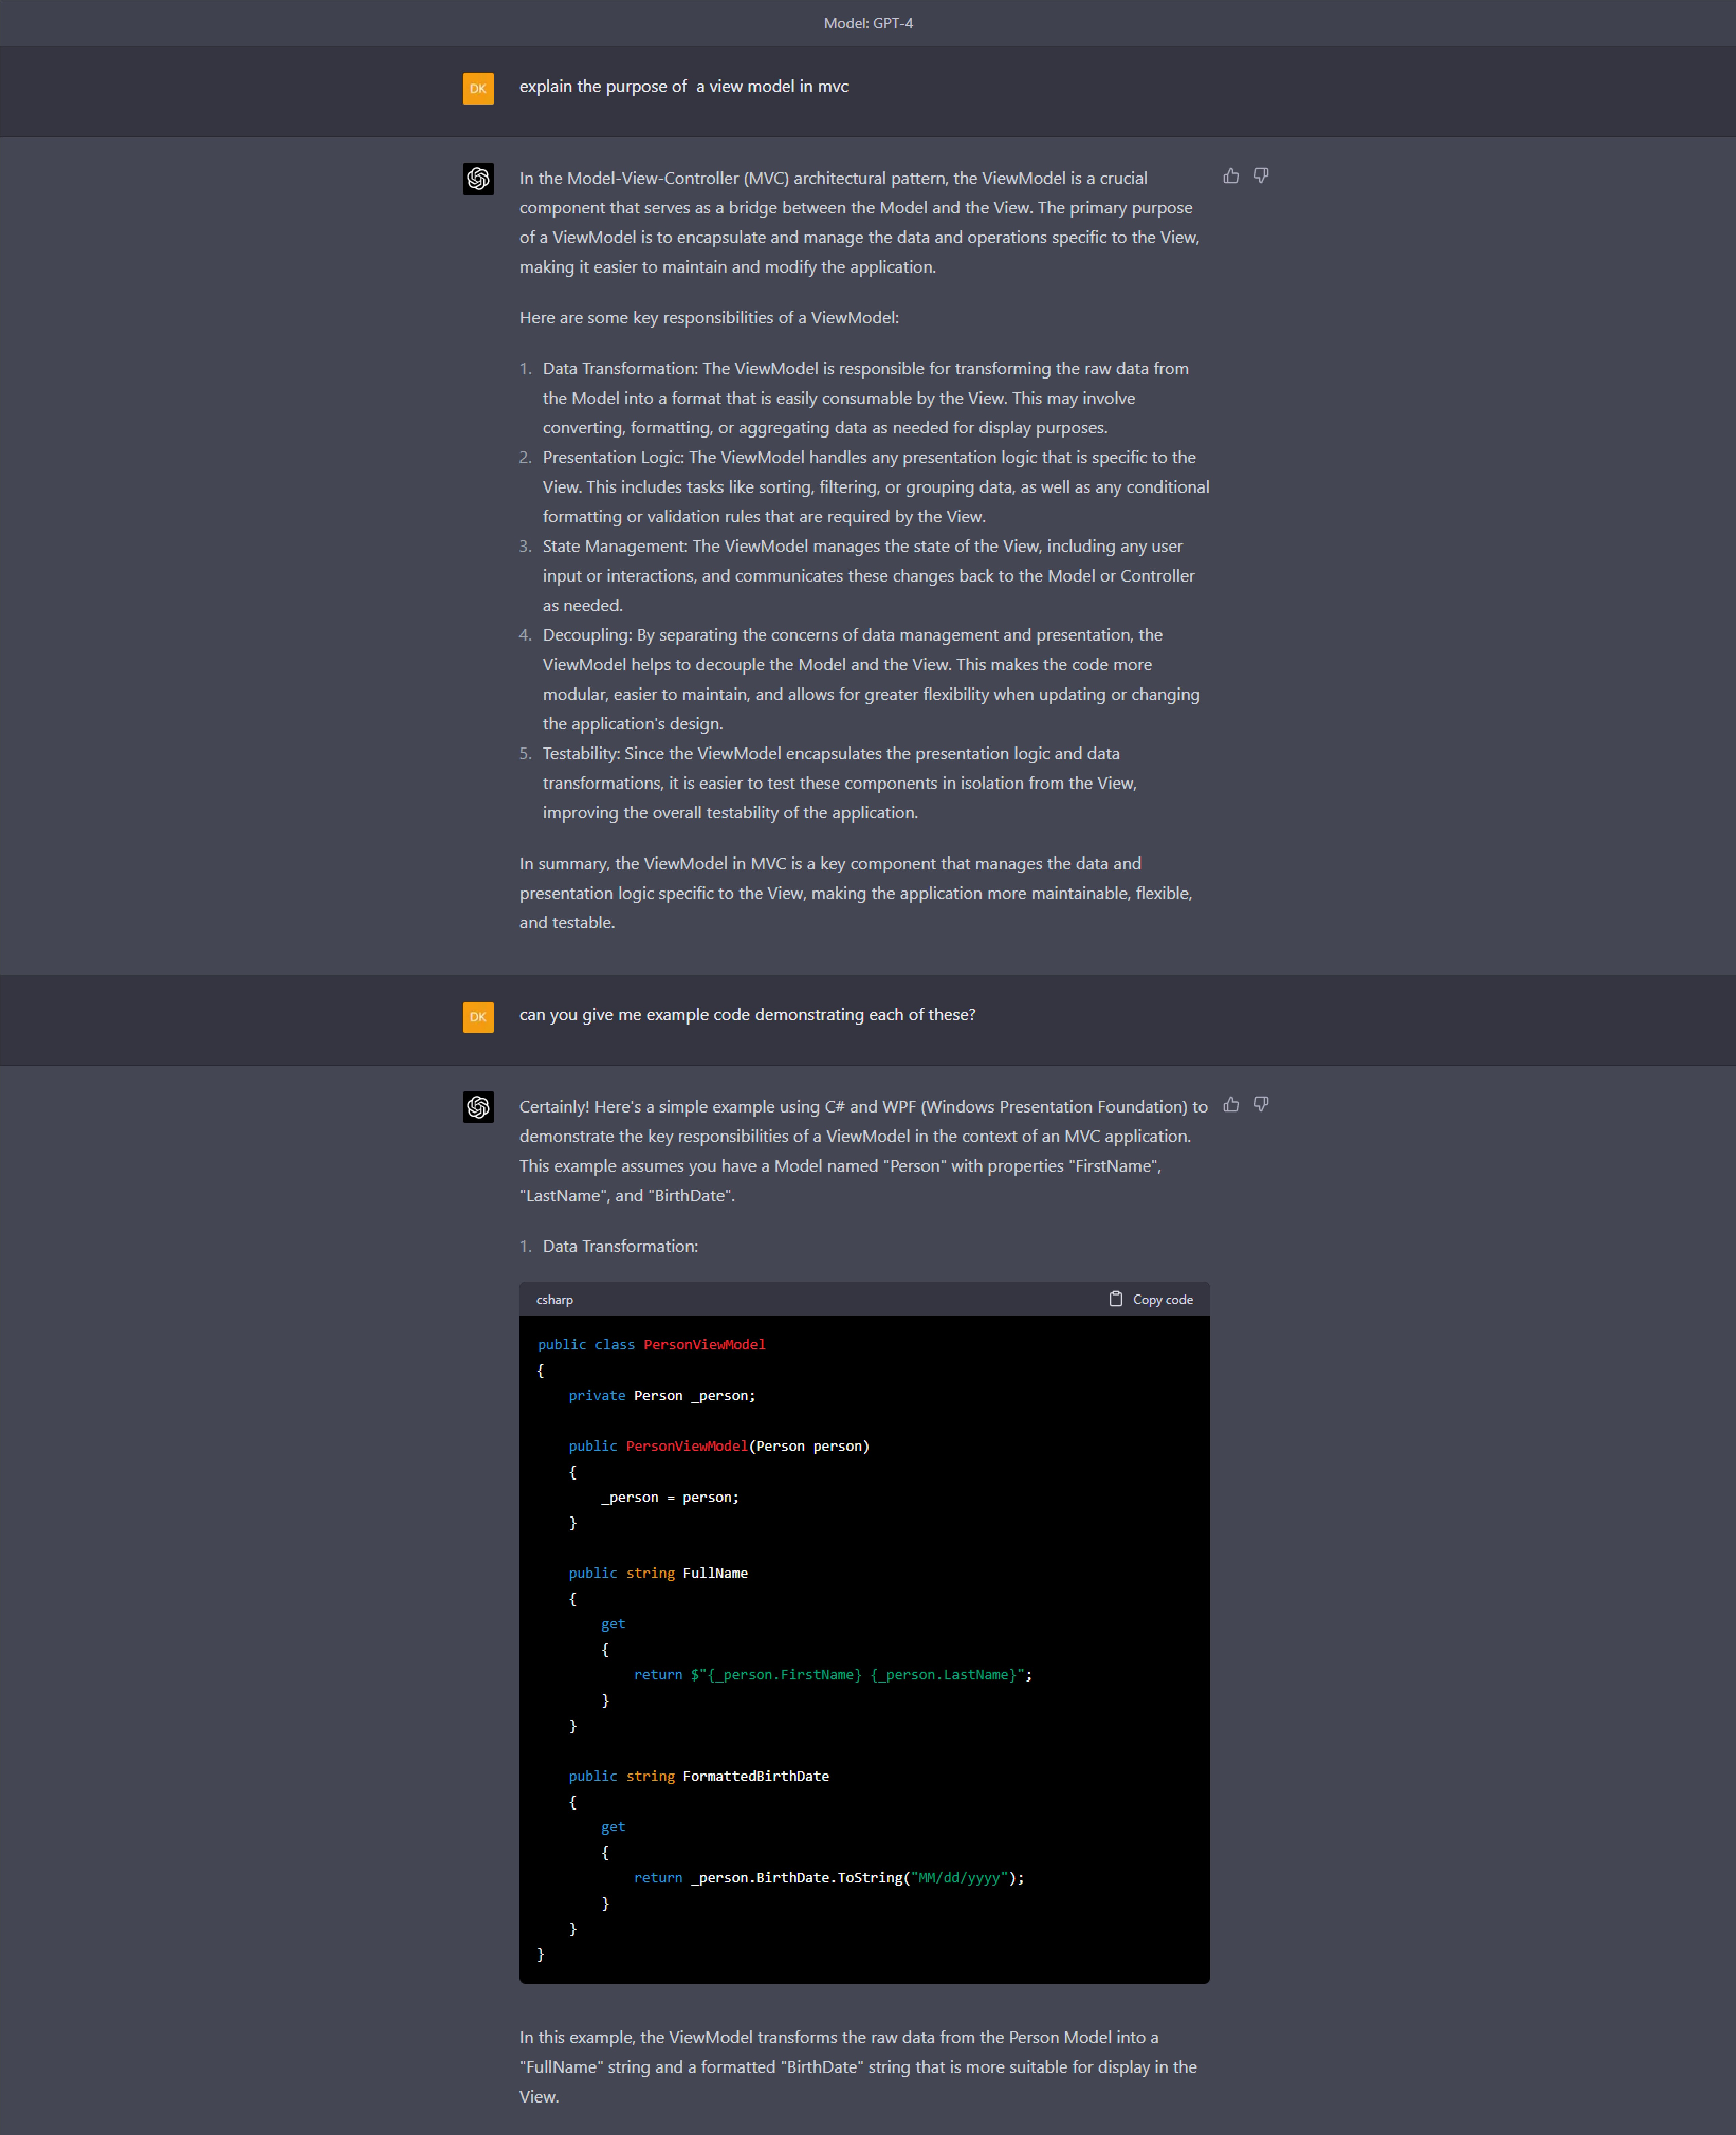

1. Presentation Logic:
   1. Copyrnde

csharp

{

ObservableCollection<Person> _persons;

(IEnumerable<Person> persons)

{

;

ObservableCollection<Person>{persons)

_persons

}

ObservableCollection<Person> Persons

_persons; }

}

(}

sortedPersons = _persons.OrderBy(p => p.FirstMame).ThenBy(p => p.LastN

_persons.Clear();

person sortedPersons)

{

_persons.Add(person);

}

}

}

In this example, the ViewModel includes a "SortByName" method that sorts the Person list

by their first and last names.

1. State Management:
   1. Copyrnde

csharp

PersonlistViewModel _personlistViewModel; PropertyChangedEventHandler PropertyChanged;

()

{

_personlistVie,.rModel

PersonlistVie

wM

odel(GetAllPersons());

}

PersonlistViewModel PersonlistViewModel

{

_personlistViewM,odel; }

{

_personListViewf'lodel OnPropertyChanged(

(PersonListViewModel));

}

}

( ,tr'rg propertyName)

{

Propertychanged?.Invoke(

PropertychangedEventArgs(propertyName));

}

{)

list<Person>

{

}

}

In this example, the MainWindowViewModel manages the state of the View by holding a reference to the PersonlistViewModel and implementing the INotifyPropertyChanged interface to notify the View of any changes.

1. Decoupling:

The ViewModel separates the concerns of data management and presentation, as seen in the previous examples. The PersonViewModel and PersonlistViewModel handle data transformations and presentation logic, while the Model (Person) contains the raw data.

1. Testability:

:You can test the ViewModel comP.onents

csharf} L)

Copycode

[Test]

public void FullNameTest()

{

var person = ne,1 Person { FirstName = "John", LastNa111e var personViewModel = ne.i PersonVie.!Model(per-son);

"Doe" };

Asser-t .AreEqual("John Doe", personViewModel. FulH11ame);

}

[lest]

public void SortByNaneTest()

{

var persons = netoJ List<Per-son >

{

new Person { FirstNarne new Person { FirstNarne

};

"John", lastName "Jane", lastName

"Doe ", *1,,*

"Doe" }

var pers

|  |  |  |  |
| --- | --- | --- | --- |
| personlistVi | | ewM | odel = |
| onlistVie | wM | odel.SortBy | |

ne111 PersonlistViewModel(persons); Name();

Assert .AreEqual("Jane Doe", personlistViewModel.Persons [0]. FullName);

}

.. . .. .



The "cannot resolve symbol" error: indicates that tlie ASP.NEli Core P-roject is missing some 

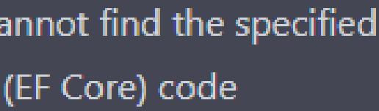

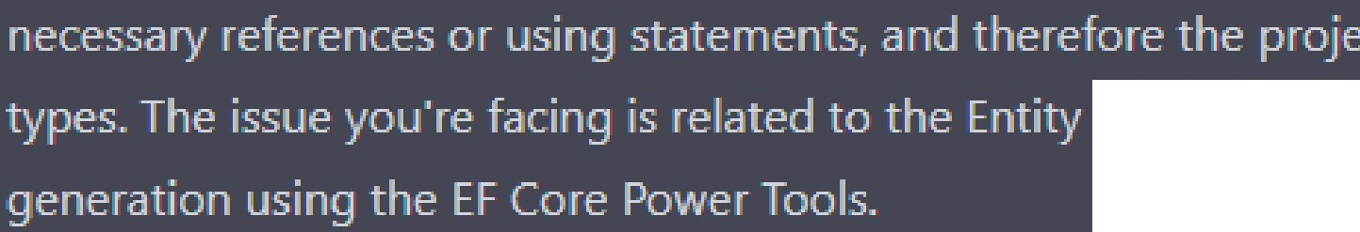

Framework Core

 NuGet P.aclcages:

**Mak'e sure** your • I • has the apP.rowiate NuGet P.ackages installed for Entiry: Frameworl<

 I

* 1. Copycode

!icrosoft.. EntityFrameworkCore Microsoft.EntityFrameworkCore.SqlServer Microsoft.EntityFrameworkCore.Tools

., ,. I - **e** bY, editing the .cswoj file:

Ll Copycode

<ItemGroup>

/ >

<PackageReference Include="Mic rosoft. EntityF rame1110rkCore" Version=·5. 0..0"

<PackageReference Include="Microsoft. EntityFrame1110rkCore. SqlServer" Version="S.

<PackageReference Include="Microsoft. EntityFrame111orkCore. Tools" Versiom="S. 0.0'

< /ItemGroup>

statements:

Check if your  have the following:

statements at

Make sure you

cstiarp L)

Copycooe

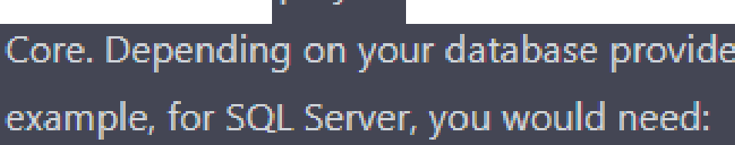

using Microsoft. EntityFrameworkCore;

using Mic rosof-1:.AspN'.etCore. Identity. EntityFrameworkCore; using Microsoft.AspN'etCore ..Identity;

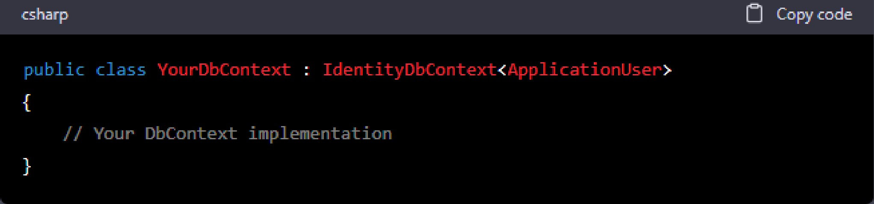

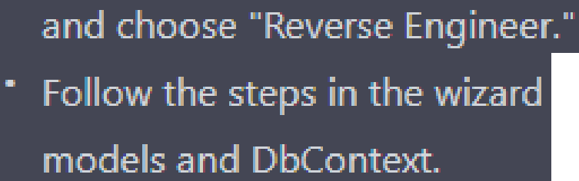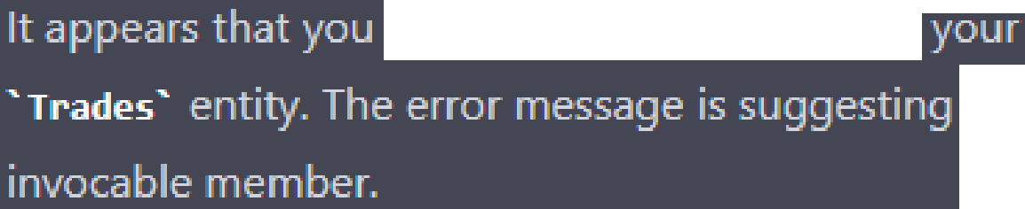

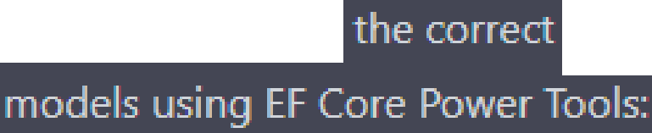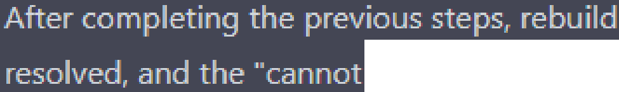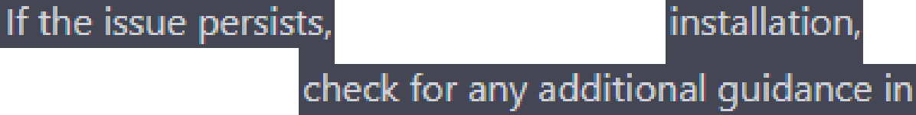

|  |
| --- |
| . .  issues afte ensuring references and using statements, trYa regenerati11g tne  Solution Elq:!lorer, rig ht-click on the P.roject,  to connect to you database and generate the ap roJ)riate  •  you solution .to.ensure that all resolve symbol" error should .. ..  double-checl<your and using statements. •  maY, also want to the woject or tool |
| d.Addressld];    d.A J)Userld); |
| have a small ntax erro in Enti!)ITyP.eBu ilder configuration for tne  that you are tn,ing to  The issue is with tne first line of the Entit TyP.eBuilde configuration:    modelBuilder.Entity<Trades(entity =>  to SP.eci the enti!Y. !YP.e and  the configuration    modelBuilder.Entity<Trades>().HasData(entity =>  corrected Enti!)'TyJ)eBuilde" configuration:  cstiarp Ll Copycode  modelBuilder.Entity<Trades>().HasData(entity =>  {  entity.Haslndex(e => e.Addressld, "IX_Trades_Addressld"L entity.Haslndex(e => e.. AppUserid, "IX_Trades_AppUserid"L  entity.Property(e => e..Descr-iption).IsRequired(); entity.PMperty(e => e..Title).IsRequil'ed();  entity.Hasone(d => cl.Addlr-ess).!.ithMany(p => p.lr-ades).HasForeignKey{d *=>* d.Addr  entity.Hasone(d => cl.AppUser-).i.ithMany(p => p.lr-ades).HasForeignKey{d *=>* d.AppL  });  cliange, the error should be resolved, and you should |
| model Builder.Entiry:<Trades> Q.HasData(entity |

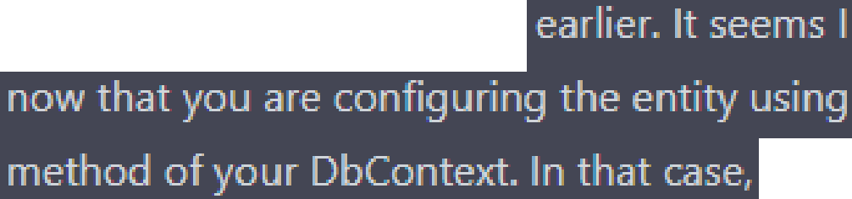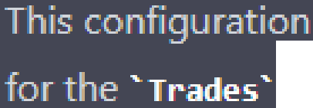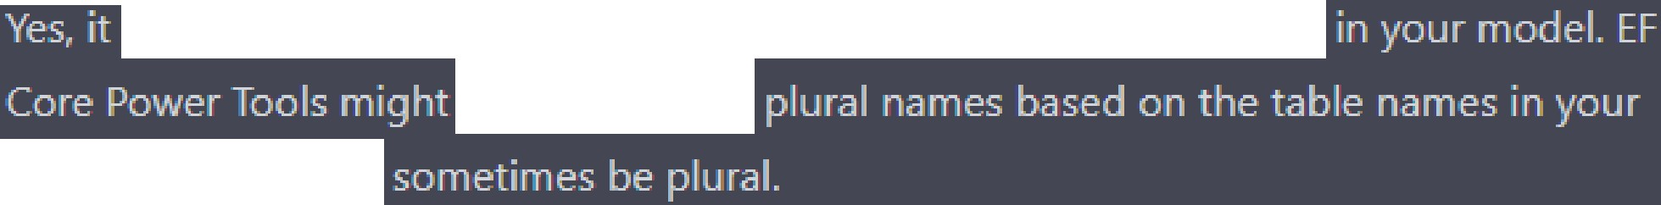

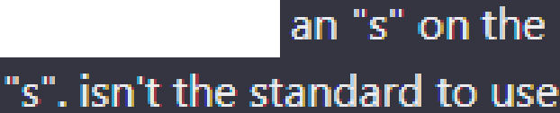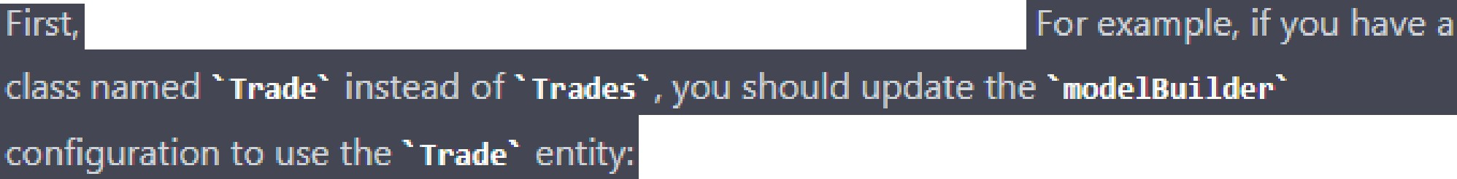

|  |
| --- |
| d.Addressld);    Ai:iologies for the confusion misunderstood ttie   the F.luent AP.I  you should use the following syntax:    is correct foo defining relationshii:is, indexes, and  enti!y: in you" DbContext.  modelbuilders using entities that are r:ilural, witli end of tlie names, of my: entities are singular, without tlie  the modelbuilder?  is **a** common convention to use **singul,u** names **for** enti!Y classes  have generated  data 1::iase, whicli can  names in tne configurations to match yom enti make sure that all your enti classes have singula" names.  cstiarp L] Copyrnde  modelBuilder.Entity<Trade>{entity =>  {  // Your configurations here...  });      tliese clianges,  **DI** |

I st cases, you don't need to extend die built-in I dentiity-related entities sudi 

**'AspNetUserLogin','AspNetUserRole''AspNetUser.loken',and** tfiey are P.art of the ASP..N Eli Core ldenti!Y. framework and common scenarios for authentication and 

**,**

 re uirements that are not covered by: the default ldenti!)'. entities, y:ou can extend them with your own custom classes. follow these steP.s:

 custom classes that Identity entities:

cstiarp L) Copy code

public class CustomUserLogin IdentityUserLogin<string>

{

// Add any additional properties or methods you need

}





P-rDP.erties o methods as

csharr:, Ll Copycooe

public class VourDbContext

{

IdentityDbContext<ApplicationUser, IdentityRole, stri

// Your DbConterl implementation

}

name of your D□Context class,

P.arameters to incluae I

configure ttie custom

I I "

csharr:, Ll Copycode

protected override void OnModelCreating{ModelBuilder

modelBuilder)

{

base.OnModelCreating(rnodelBuilder);

{

});

=>

// Your configurations for the custom entity

modelBuilder.Entity<CustomUserLogin>(entity

// Other modelBuilder configurations...

}

framework, and



your custom

..

re uirements. However, remembe ttiat extenaing 6uilt-in ldenti!Y.entities can

comrJlexiJy and -



The !YP.e or namesP-ace name 'tyP.e/namesP.ace' could

or an assembl

directive

,y reference?) foe asP. identi!}'. related

in dl:5 context file.

I shouldnt create them manually,

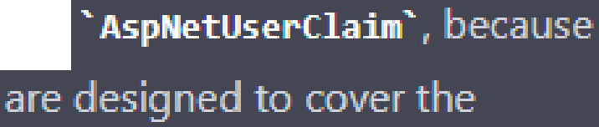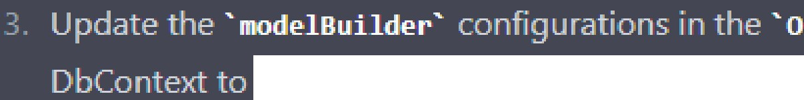

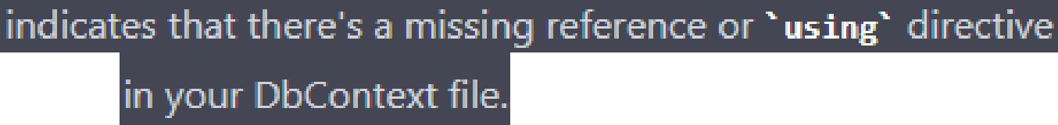The erro you 're encountering 

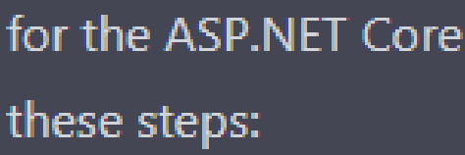ldenti!)'. classes To resolve this issue, follow

 P.ackages installed   need to have the following 

L) Copycode

Microsoft.AspNetCore.Identity.EntityFrameworkCore Microsoft.EntityFrameworkCore Microsoft.EntityFrameworkCore.Design Microsoft.EntityFrameworkCore.Tools

may also need to 

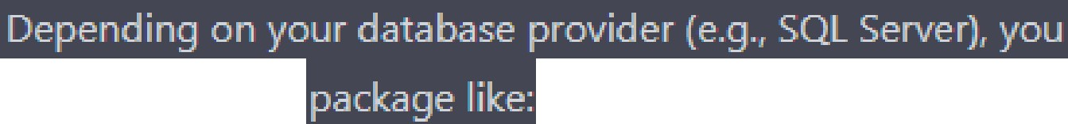

P-rovider-s P.ecific



Microsoft.EntityFrameworkCore.SqlServer

